EMS and Municipal COVID-19 Screening:
Protecting first responders and city workers during the pandemic
Real world data from LAMP surveillance programs

Prepared by:
Randy True – Founder and CEO, FloodLAMP Biotechnologies, PBC
randy@floodlamp.bio

Theresa Ling – Program Experience and Design, FloodLAMP Biotechnologies, PBC
theresa@floodlamp.bio
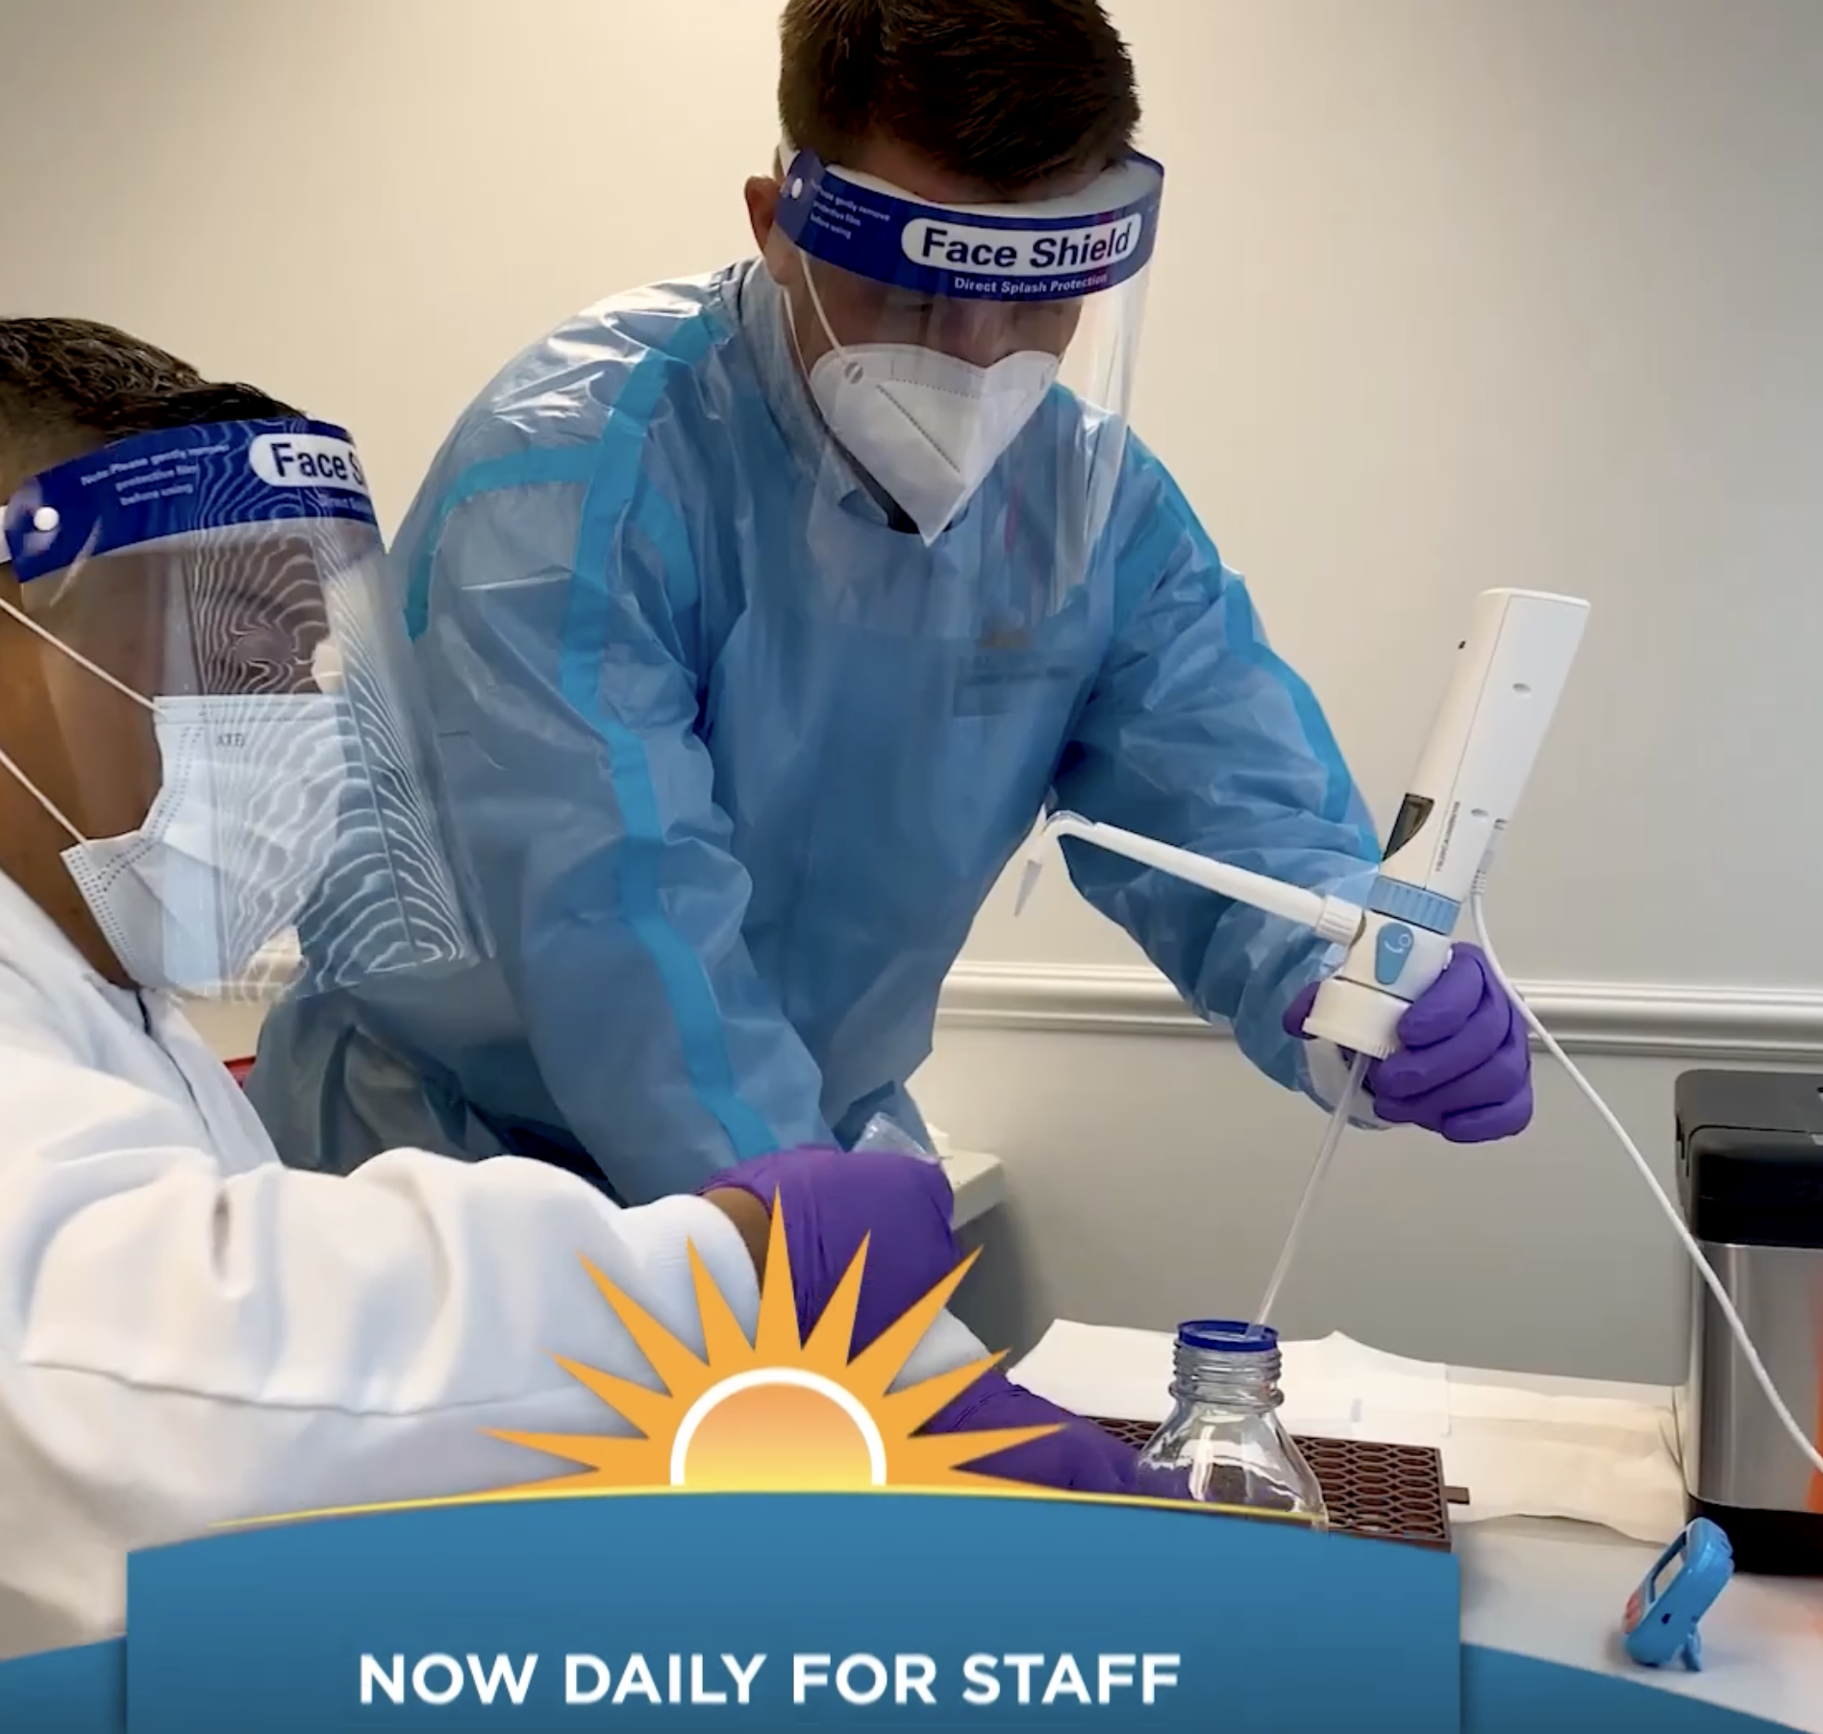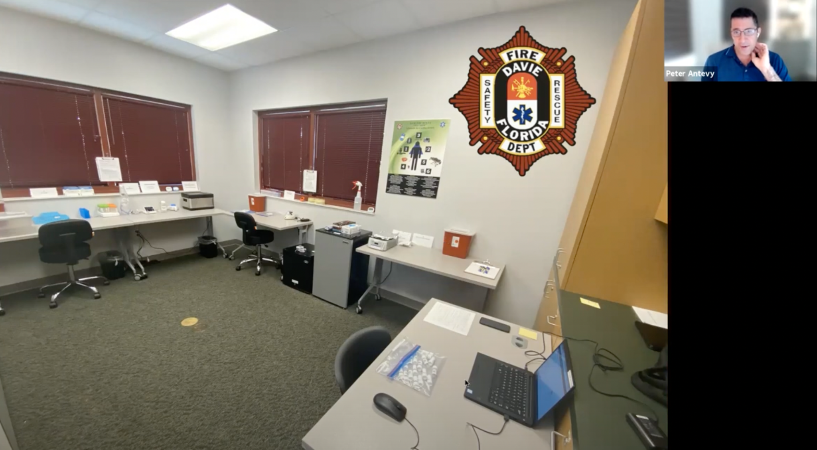

Table of Contents
Table of Contents 2
About FloodLAMP 3
Overview of FloodLAMP Surveillance Screening 3
FloodLAMP and EMS 3
Early stages 3
Coral Springs and Davie 3
Bend 4
Omicron Surge 4
Coral Springs and Davie 4
Bend 5
Case Study 1: Fast turnaround time to stop spread 5
Case Study 2: Accuracy of FloodLAMP vs Antigen 6
Program summary: how it works 6
Set up: lab and staff training 6
Processing and turnaround time 7
Impact and outcomes 7

About FloodLAMP
FloodLAMP’s mission is to enable globally scalable mass disease screening, for COVID-19 and beyond. We are a Public Benefit Corporation focused on accurate, accessible, decentralized molecular testing. We have innovated on multiple fronts to create a best-in-class platform that is unique in the testing space. The test itself is instrument-free, extraction-free rapid molecular LAMP. The results are visually read with a simple color change. We are expanding to high priority populations during the pandemic to address the acute unmet need for accessible, effective testing. For more about our programs, plans, mission and how you can get involved, please contact us through our website at floodlamp.bio.

Overview of FloodLAMP Surveillance Screening
“Surveillance” is the technical term for testing that is non-diagnostic and not medical. Surveillance testing or screening looks for infection in a population or community, and has expanded greatly during the COVID Public Health Emergency. The information from surveillance testing can be used for the purpose of stopping the spread of the disease and for managing risk mitigation measures for the group. No exchange of personal health information is required for surveillance. Further, a much greater degree of flexibility in where and how testing is implemented enables programs such as FloodLAMP’s to better meet the needs of groups looking to interact more safely.

FloodLAMP and EMS
The capability FloodLAMP enables has found a natural fit with the EMS community. The importance of low absenteeism for first responders cannot be overstated, as there are multiple negative downstream effects of reduced staffing such as longer 9-1-1 call wait times, longer ambulance response times or disruptions in fire services.

FloodLAMP has 3 EMS surveillance programs operating in 2 states, screening first responders and municipal workers: Coral Springs, FL, the town of Davie, FL, and Bend, OR. These departments adopted and scaled an ambitious in-house program for rapid molecular screening to enable resiliency, local control, and the ability to test on their own custom schedule. The outcomes of the programs have resulted in reduced staff outages, increased safety, and further investment in this capability. We believe the program described below is among the most effective and affordable COVID suppression approaches. It rivals and potentially exceeds expensive testing programs used in sports and entertainment, and can serve as a model to be scaled nationally and globally.

Early stages

Coral Springs and Davie
In June 2021, FloodLAMP, in partnership with NSVD (National Scientist Volunteer Database) and Research Aid Networks, provided COVID screening for an EMS leadership conference.

One EMS leader then used FloodLAMP to successfully screen a teen summer camp his children were attending in July 2021. Based on that experience, he made the decision as Chief Medical Officer for the EMS departments in Coral Springs and the Town of Davie, FL in Broward County to institute FloodLAMP’s screening program for these departments in early August 2021. On November 15, 2021, the Town of Davie made the decision to extend voluntary screening to all municipal workers.

Bend
The EMS department at Bend, OR was aware of the successful screening program running at Coral Springs and Davie. They became interested in bringing up in-house screening to screen a small number of samples per week from unvaccinated individuals to remain in compliance with COVID guidelines. The convenience and affordability of the FloodLAMP program was a good fit for this need and helped to reduce costs incurred by PCR testing. Bend’s entire lab set up and training was supported remotely by FloodLAMP staff in early December 2021, in collaboration with a volunteer scientist from a local education nonprofit.

Omicron Surge

Coral Springs and Davie
Between late September to early December 2021, both Coral Springs and Davie experienced low prevalence and did not detect any unknown positives with FloodLAMP. This quickly changed with the rise of the Omicron surge in early-mid December. Because the screening capability was already in place, they were able to quickly ramp up testing to meet the sharp surge demand, scaling from [low number] to [high number] with the addition of [how many staff? What kind of schedule?]. This proved to be incredibly valuable in protecting their critical human infrastructure and minimizing outages.
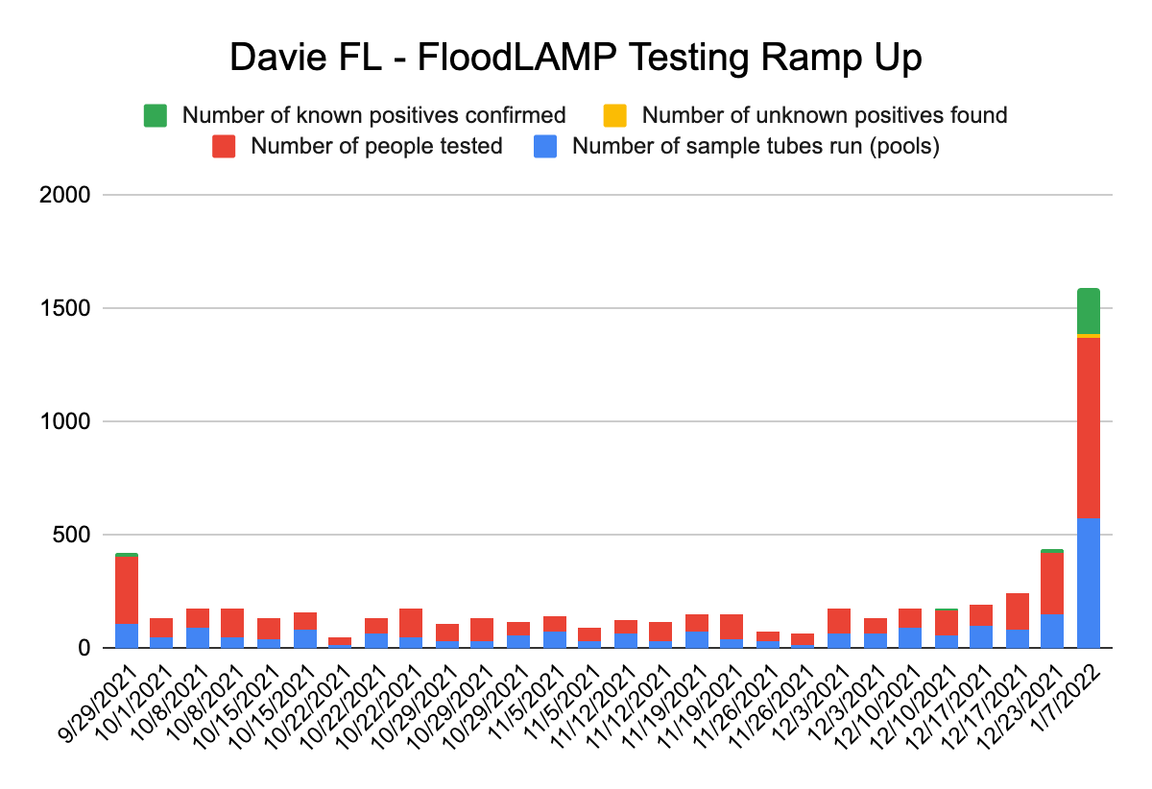

In terms of reliability, FloodLAMP’s screening became the go-to testing modality over slower, expensive lab PCR and less accurate antigen tests during this surge. Turnaround time for PCR results in this area was averaging x-x days between date- date.

Bend
The introduction of Bend’s screening program happened to coincide with the period just before the Omicron wave. Bend’s timing on establishing their screening capability could not have been better planned to handle the Omicron surge. For their first three weeks in operation, they screened a small number of weekly samples, but immediately following the Christmas holidays, the surge hit and they were able to more than quadruple their testing because of their established set up, finding dozens of unknown positives and protecting their workforce. This was achieved with minimal additional labor and a single re-order of supplies from FloodLAMP.
[chart: 0 unknown positives from Dec. 7-Dec. 27 to 171 from Dec. 28-Jan. 24]

“It’s been a godsend,” their EMS Training Officer running the program told FloodLAMP. Every positive they have screened has been confirmed by PCR.

Case Study 1: Fast turnaround time to stop spread
A member of top leadership at the Town of Davie turned positive. His entire family was immediately sampled. 1 of 2 children positive, that child kept home from school, potentially stopping spread in school.
Need dates, any other testing performed?

Case Study 2: Accuracy of FloodLAMP vs Antigen
Described in recorded interview in Jan 2022:
22 positives in 1 day
Thought it was a mistake, reran all samples – all positive
All participants reflexed to antigen (BinaxNow) – only 1 came back positive
All people returned to work
1-2 days later, all were positive by antigen (how many days?)

Program summary: how it works

Set up: lab and staff training
Securing appropriate space on-site and in-house staff to run the test were the first steps in kicking off these projects. Both departments were able to allocate a single empty room for lab space and one light-duty firefighter to run the assay. FloodLAMP staff were on-site at kick off to consult on lab set up and provide training for running the assay. Consultation and training are now also available as remote services and certifications.
Program management
Each deployment has a functional Program Administrator who manages the organizational aspects of the screening program, including onboarding for participants, sample collection, clinical referrals, and reporting. Each department has customized aspects of the program to fit their staff profile and needs. These functions may be assisted by FloodLAMP’s digital tools.

FloodLAMP app for (pooled) sample collection

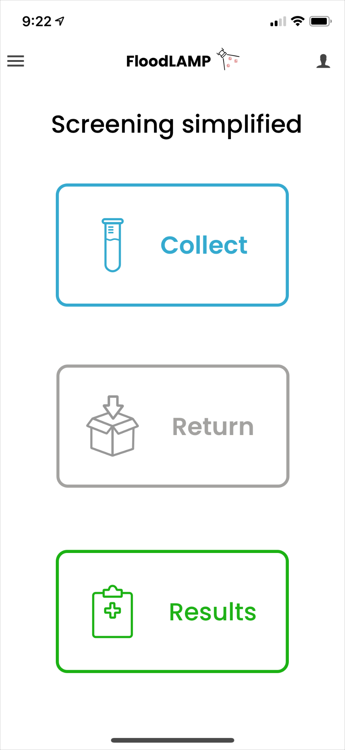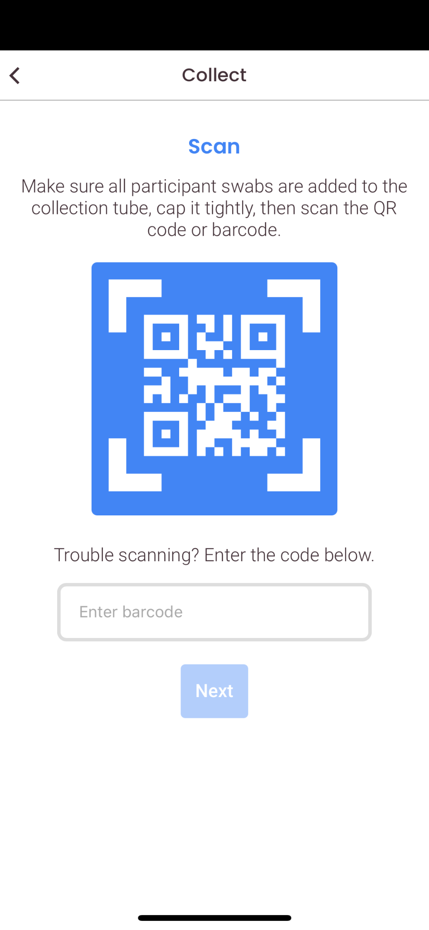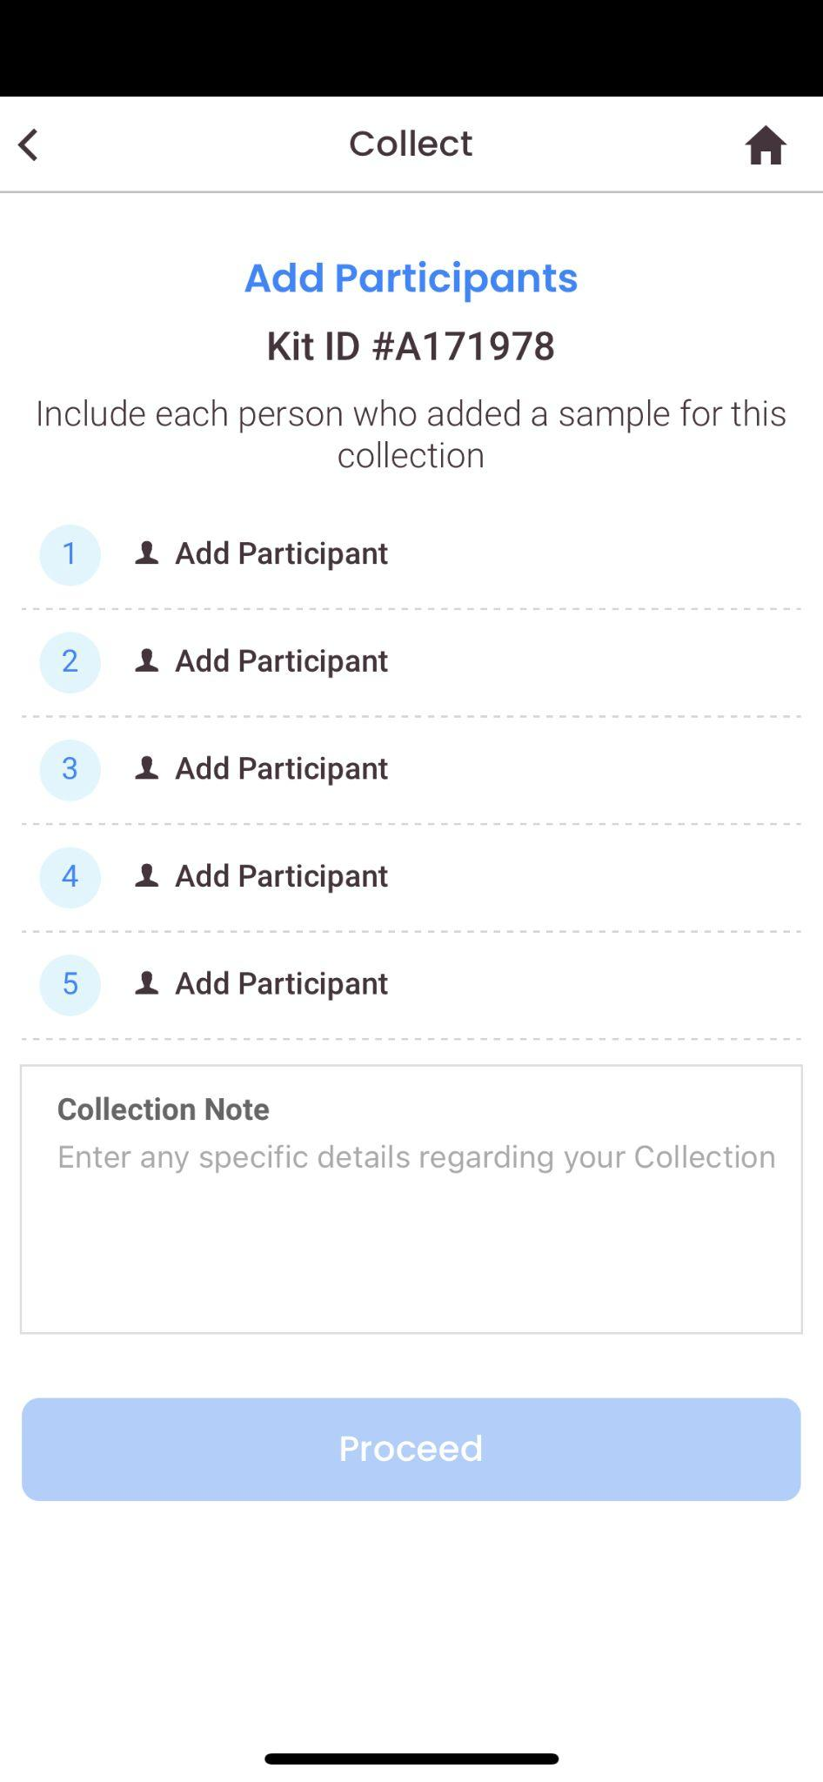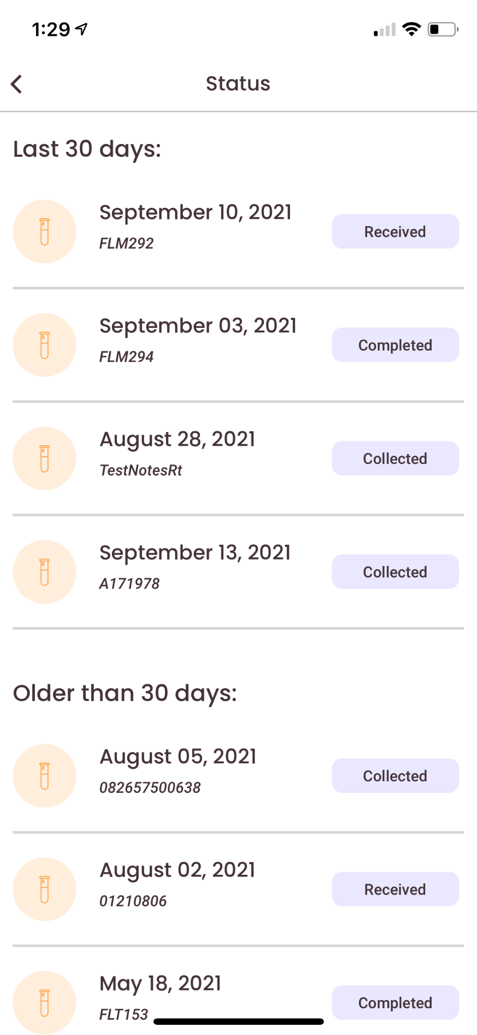

Admin Portal for account management and reporting

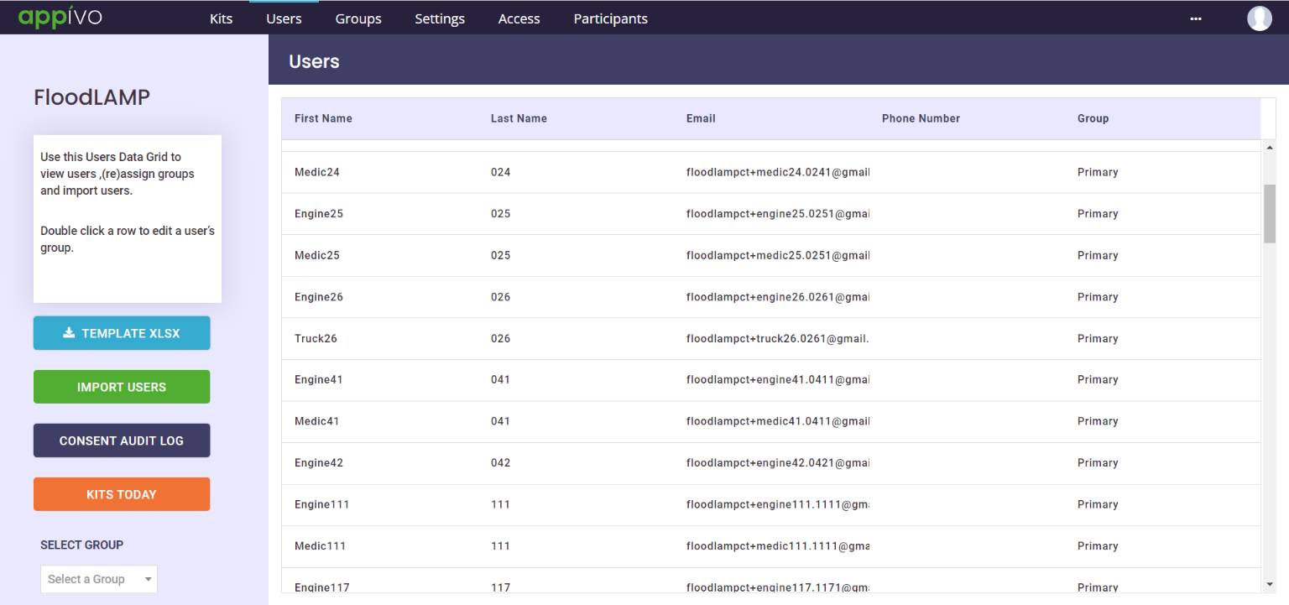

Processing and turnaround time
In-house lab staff process the samples on the collection schedule determined by the Program Administrator. Our deployments have been able to routinely turnaround results in under 2 hours.

Impact and outcomes
All 3 deployments have been able to successfully screen and capture unknown positives to protect the safety and health of their workforce through the Omicron surge.
At the peak of the surge for Coral Springs and Davie, these departments experienced about 12% absenteeism vs. roughly 30-35% absenteeism in neighboring departments.

Tube pics?
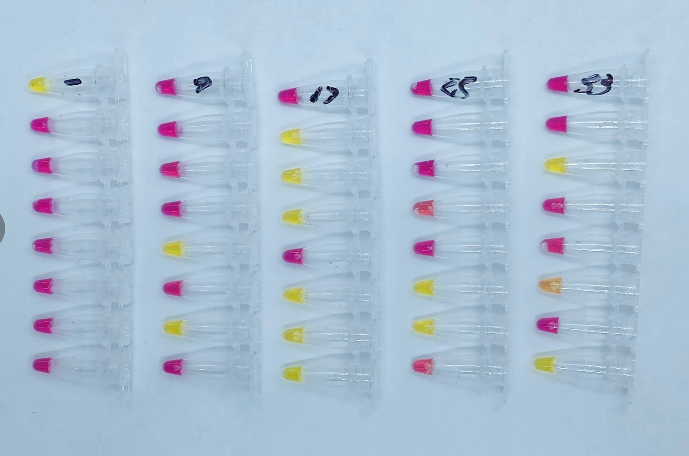 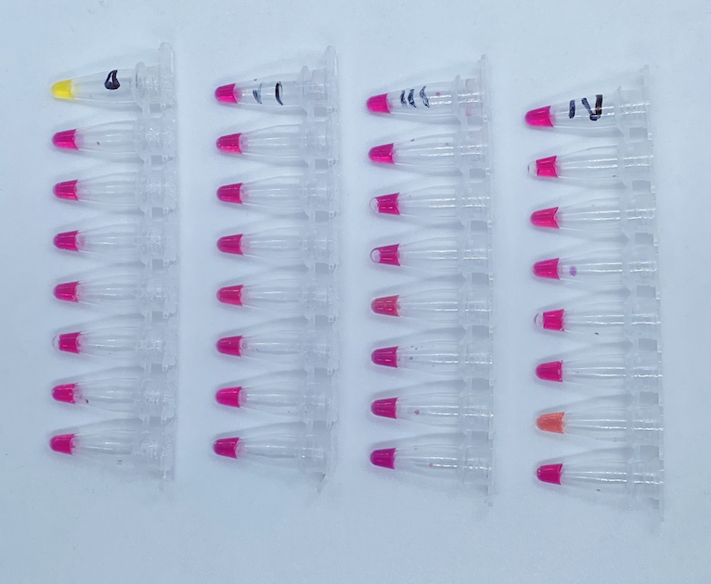
Yellow = positive (each run has 1 positive control)
Pink = negative

FloodLAMP’s program was already well regarded by each deployment in terms of its cost-effectiveness and convenience before Omicron. After Omicron hit, however, the program’s surge capability exceeded expectations and each deployment was able to scale quickly to meet the needs of its population. The feedback from each deployment and the people they serve has been overwhelmingly positive:

“FloodLAMP has saved us countless hours of our staff waiting in lines to get tested. This has given many families peace of mind or forewarning. If testing is easy and prompt, people will do it.“
- EMS Training Officer and Paramedic

“I’m done with PCR.”
- Fire Chief running FloodLAMP

“This allows me to bring in PCR-level quality testing that we can run within an hour ... I can test thousands of people if I want to.”
- Chief Medical Director at Coral Springs and Davie

Outline (CS and Davie)

Introduction
- These first 2 depts boldly adopted ambitious in-house program for rapid molecular screening. This enables:
  - Resiliency
  - Local control
  - Ability to test on a custom schedule
  - Reduced staff outages
  - Increased safety

How it began
- FloodLAMP tested the EMS leadership conference in June 2021 with partners at NSVD and Research Aid Networks.
- This led to important connections. One leader took system to summer camp to test kids.
- Based on that experience, he brought FloodLAMP to his EMS departments in FL, early August 2021 (Delta surge?)
- Numbers of people screened per week? Schedule? Was is mandatory?

Omicron
- Went from optional to mandatory
- Scaled up to meet demand
- Depts have moved to FL as go-to testing over antigen and PCR (can we cite reasons why? Do we have data for failures of antigen and PCR?)

Case studies (Omicron)
Leader @ Davie
- Person turned positive. His entire family was immediately sampled.
- 1 of 2 children positive, that child kept home from school, potentially stopping spread in school.
- Need dates, any other testing performed?

Tester @ CS
- 22 positives in 1 day
- Thought it was a mistake, reran all samples – all positive
- All participants reflexed to antigen (BinaxNow) – only 1 came back positive
- All people returned to work
- 1-2 days later, all were positive by antigen (how many days?)

Outcomes
- Further investment in this capability
- Model for other EMS departments, we have multiple inquiries and increased demand
- X staff members trained (do we have exact number?)
- Do we have data for plot chart similar to Carillon write up? Pics of tubes, plates? Comparison with antigen?
- Chart with the testing increase with positivity

- Able to move from nonDx test to Dx test to therapeutics as needed (number of people hospitalized?)

** From Medical Director
He will connect us with Data Scientist at CS
- Keeping tabs on HR/data since beginning of pandemic
- Uptick in usage of FL
- About 12% at peak of employee absenteeism (heard it was somewhere in 30-35% absenteeism that led to shut downs)
  - Lauderdale, a few other places
  - Coral Springs has about 1200 people across area
  - Never had to shut down a station

IRB – friends of broward county, anonymized, 20 cities in this area, 5-7 question survey
- Absenteeism (week by week) during Omicron
- Model used for testing/suppression
- Look for patterns in conjunction with modality
- Look back at information for the next wave in terms of best practices

Sunrise (Brouard County) – they went full herd immunity
- Fire chief is getting raw data from this city
City of Hollywood

Good stories:
- Kept city open
- People avoiding long lines and long waits for results
- Therapeutics access from early infection detection (hospitalization) – CS Data Scientist has # of people who got therapeutics

Outline (Bend)

How it started
- Invested in capability before Omicron
- They were checking a compliance box – low cost alternative to expensive PCR ($100 pp/test)
  - FL charged $6/reaction (can pool to 2 with mini system but they have only run individual4)
- Mandatory for unvaxxed people
- Ran 20 samples/week

During Omicron
- Ramped up to meet demand
- Reorder
- “Godsend”

Outcome
- Ability to immediately move to testing entire fire department when surge was needed
- With existing capability, were able to increase to meet demand (just involved moderate amount of additional staff time)

Can we get from Medical Director: (by city)

- Total ppl screened over time + test positivity and absenteeism
- # people referred to therapeutics, vaccination status and hospitalization rates of those people
- Leader @ Davie’s story of showing up positive on FL
  - Do we have data from his and his family’s follow up tests?
    - FL: result, date sample was taken
    - Antigen: brand and result, date sample was taken
    - PCR: result, date sample was taken, date result received

- We also want the larger data set on follow up tests for positive screens from FL
  - FL: result, date sample was taken
  - Antigen: brand and result, date sample was taken
  - PCR: result, date sample was taken, date result received
- Additional information
  - From Coral Springs Tester
    - story about 22 positives (is that number right?)
      - Can we pull data from FL and follow up tests:
        - FL: result, date sample was taken
        - Antigen: brand and result, date sample was taken
        - PCR: result, date sample was taken, date result received
    - Do we have pics of tubes from those days?
  - Number trained at CS
  - Total people trained to run assay at start of program
  - Total people trained to run at present
    - Were additional people trained during Omicron surge?
    - How long did that training take?
  - What was screening schedule at start of program?
  - What was screening schedule during surge?
  - Was there a change in schedule during Delta surge?

